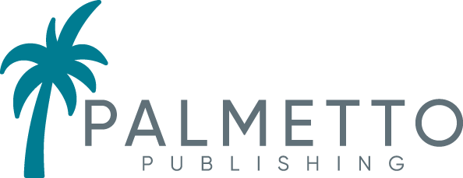 Palmetto Publishing
Phone: 888-457-9395
Info@PalmettoPublishing.com
www.PalmettoPublishing.com

For Immediate Release
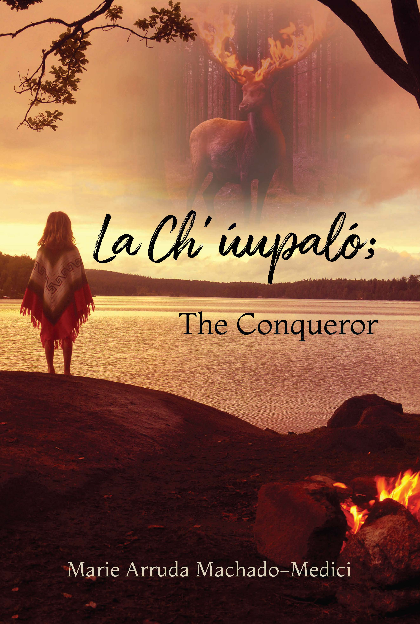
New YA novel’s heroine makes tolerance her mission

La Ch’ úupaló; The Conqueror by Marie Arruda Machado-Medici
ISBN: 978-1-63837-786-3
Publication Date: Available now on Amazon

As a mother, Marie Arruda Machado-Medici taught her children to be kind and considerate of all people. “I believe all people deserve to be treated with dignity and kindness,” Machado-Medici said. Aiming to spread the message of kindness and tolerance to younger generations, Machado-Medici has penned a YA fantasy novel centered on an indigenous teenage girl with a strong sense of morality and a big heart.

In La Ch’ úupaló; The Conqueror, Alyak knows her mind and is determined to combat prejudice and save her tribe – and maybe even change the world. Defying her father, she resolves to alter the course of her tribe’s future and earns the respect of the warriors, including her grandfather, in the process. Machado-Medici also introduces a love interest for her heroine, but she maintains it isn’t the primary focus of the novel. “For Alyak, if a knight in shining armor comes along, well, great, but she definitely knows how to take care of herself,” Machado-Medici said. “The romantic element is entertaining, but my hope is for readers to be able to relate to the characters and be inspired by Alyak’s strength, perseverance, and loyalty to her family and heritage.”

La Ch’ úupaló; The Conqueror is available for purchase online at Amazon.com.

About the Author
Marie Arruda Machado-Medici is a special education teacher and military veteran. She has spent time working in juvenile detention centers teaching young people. She is a United States citizen but also has several First Nations tribal affiliations. When not teaching or writing, Marie enjoys studying genealogy and archaeology. She has three daughters and two grandchildren.

MEDIA CONTACT:
Marie Mercado
Mariemercado36@icloud.com

REVIEW COPIES AND INTERVIEWS AVAILABLE

###

